PERSONAL DATA APPLICATION FORM

General Disclosure:

Within the scope of Lay No: 6698 on Protection of Personal Data, Personal Data Owners (“hereinafter shall be referred to as “Applicant”) have been granted the right to make demands about the processing of personal data as per Article 11 of the LPPD. As per Article 13 of LPPD, applications thereof should be submitted in writing to our Company which is also Data Supervisor. Applications to be made “in writing” can be delivered to our Company using this Form in person or through Notary. Such applications will be responded within latest thirty days following its delivery to us.

Applicant Details

Name Surname
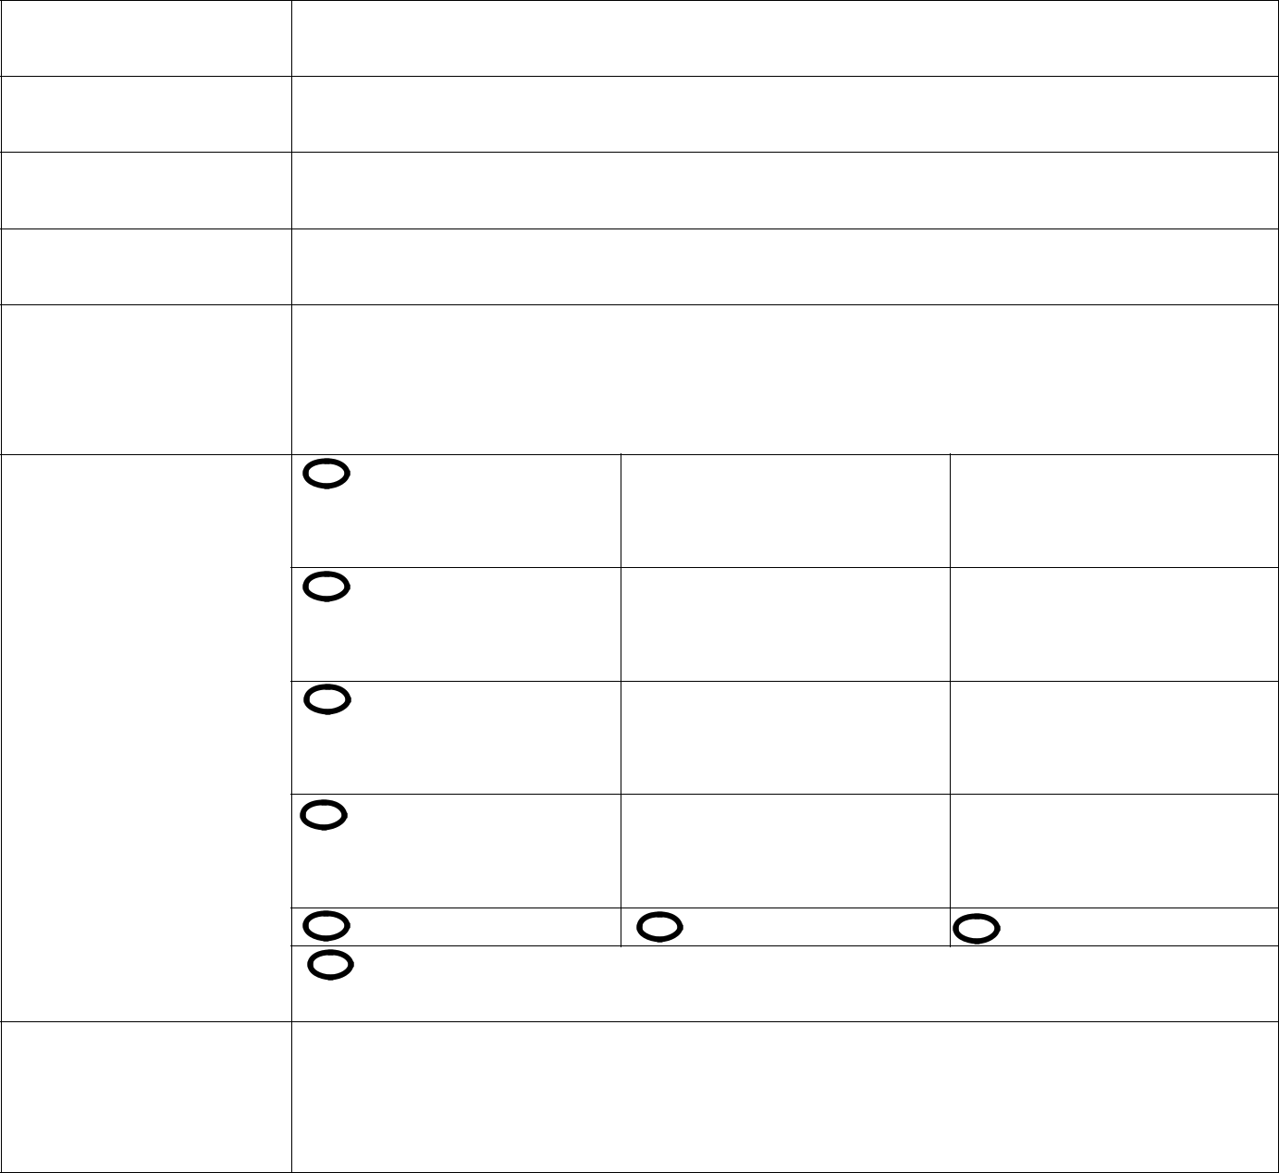
TR ID No

Telephone No

E-Mail Address

Address

His/her relation with our Company | Current Employee | Unit/Position
 | Former Employee | Date Range of Employment/  Position
 | Employee Candidate | Application Date/Position
 | Subcontractor staff | Company/  Position
 | Customer | Visitor | Shareholder
 | Other……………………………………………………………………………………………………
 | ……………………………………………………………………………………………………………………
Unit contacted in our Company/Subject

 | Method of response to your application |  | Mail to address |  | E-Mail to My E-mail Address |  | By hand


Your request in details:

………………………………………………………………………………………………………………………………………………………………………………

……………………………………………………………………………………………………………………………………….……………………………………

………………………………………………………………………………………………………………………………………………………………………………

………………………………………………………………………………………………………………………………………………………………………………

………………………………………………………………………………………………………………………………………………………………………………

………………………………………………………………………………………………………………………………………………………………………………

………………………………………………………………………………………………………………………………………………………………………………

………………………………………………………………………………………………………………………………………………………………………………

………………………………………………………………………………………………………………………………………………………………………………

………………………………………………………………………………………………………………………………………………………………………………………………………………………………………………………………………………………………………………………………………………………………..

This Application Form has been drawn up to determine your relation with our Company and to respond you in timely manner. Our Company reserves the right to demand additional documents (ID Card etc.). Our Company bears no responsibility for the requests from unauthorized application sources.

Applicant (Personal Data Owner)

Name Surname

:

Application Date:

Signature

:

